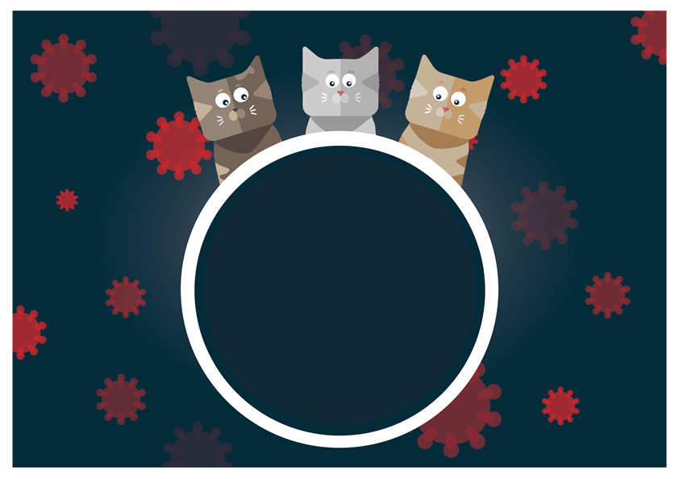
Your Practice Social Media Toolkit for Feline Diseases
UK-NOV-260600006
Feline Leukaemia Virus

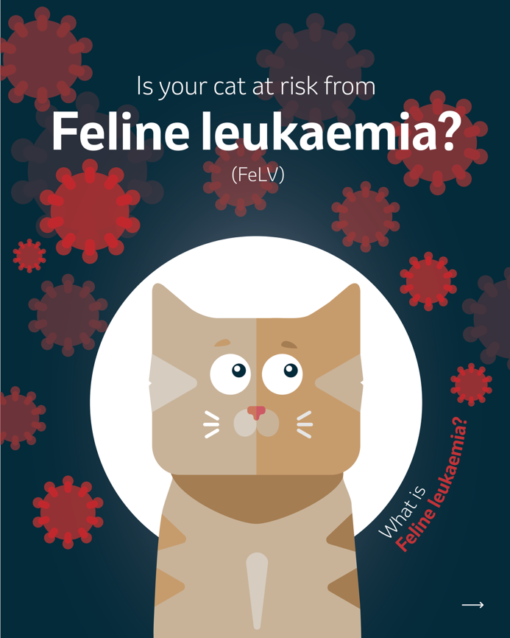 | 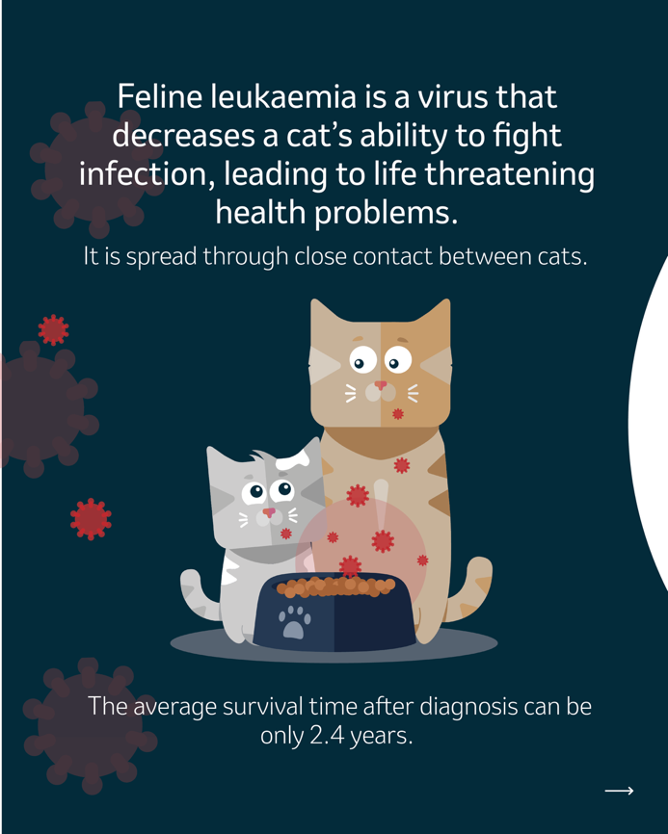 | 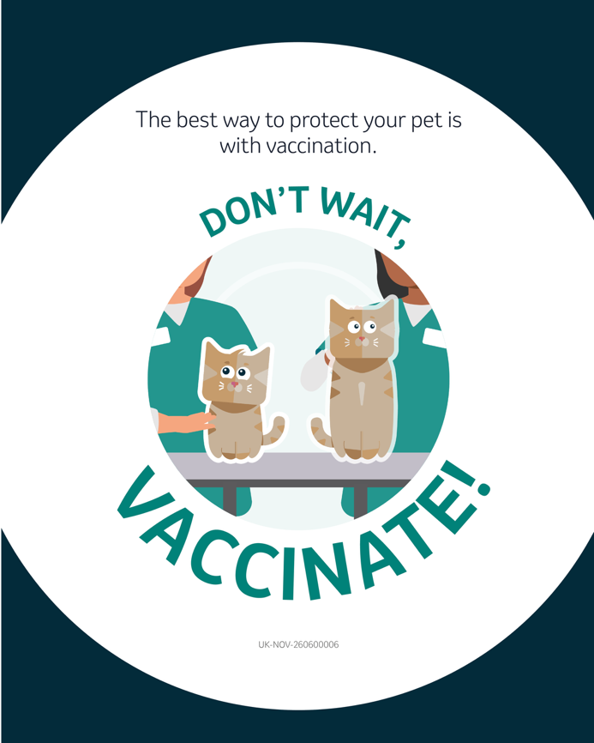
Suggested Caption: Feline leukaemia virus can be fatal. The best way to protect your them is through vaccination. Don’t wait, vaccinate!

Cat Flu

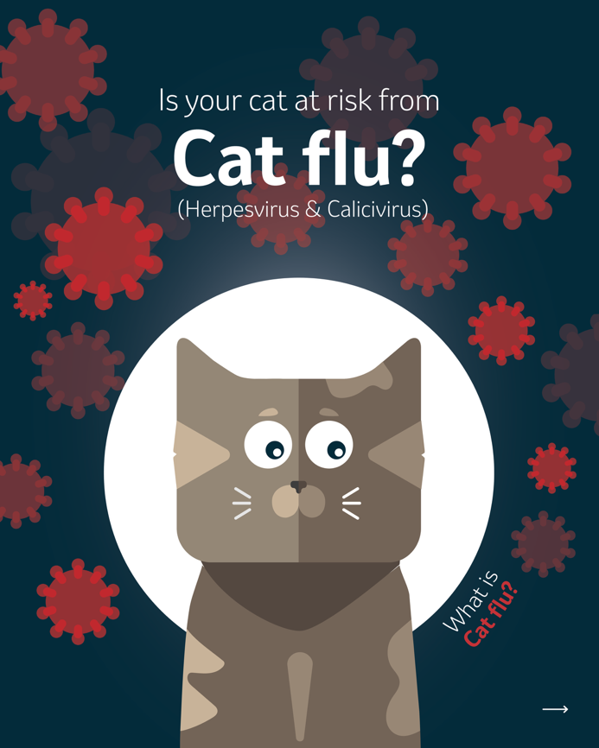 | 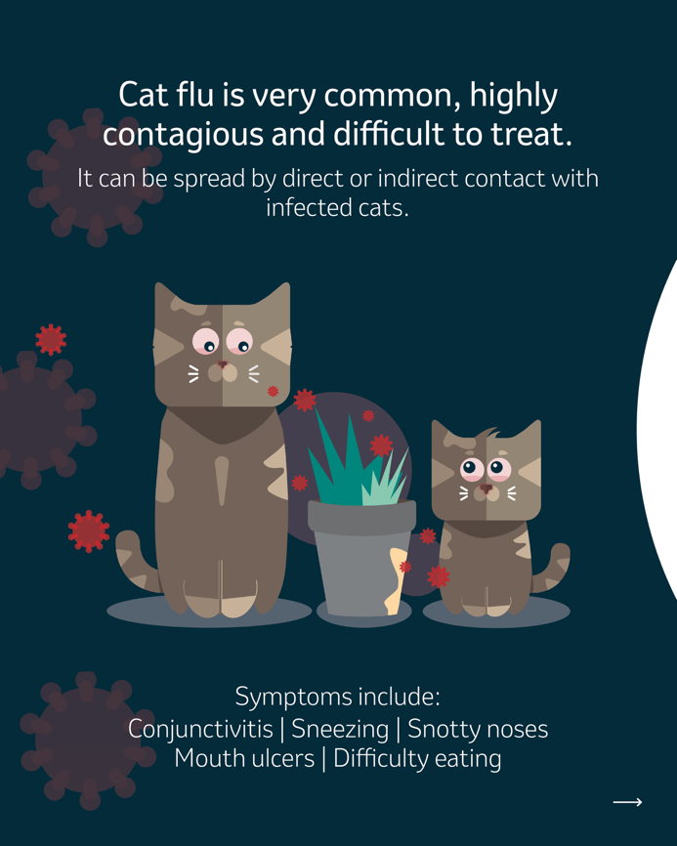 | 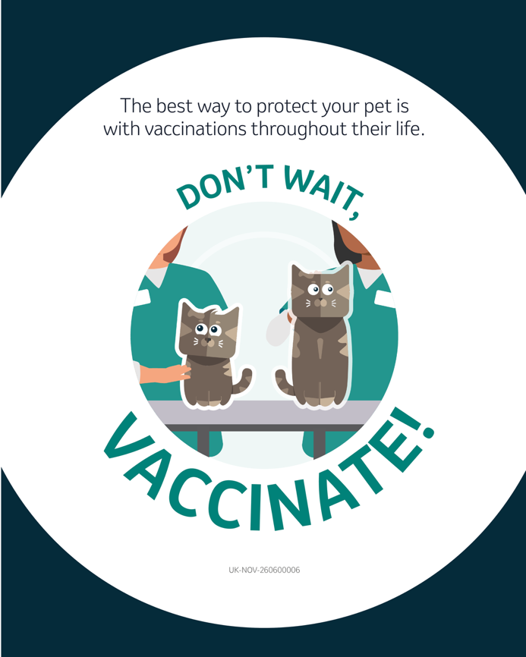
Suggested Caption: Cat flu is a potential threat for all cats. It is a highly contagious and widespread disease associated with serious and sometimes long-term illness. The best way to protect them is with vaccinations throughout their life. Don’t wait, vaccinate!

Panleucopenia

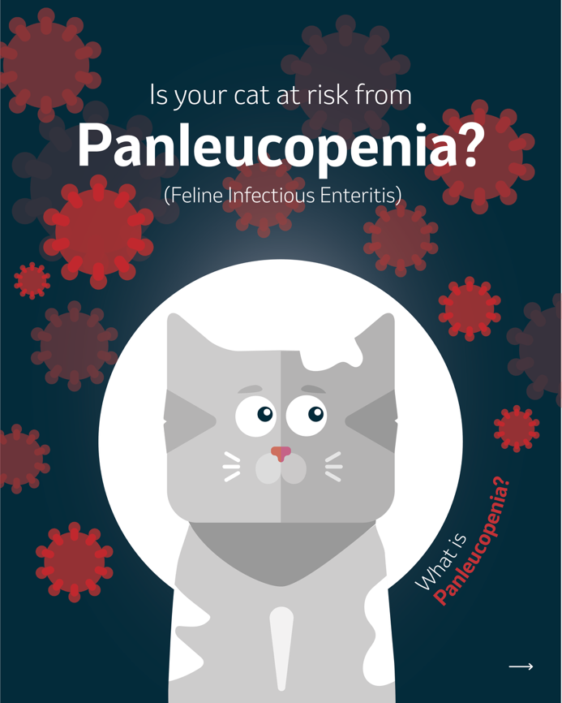 | 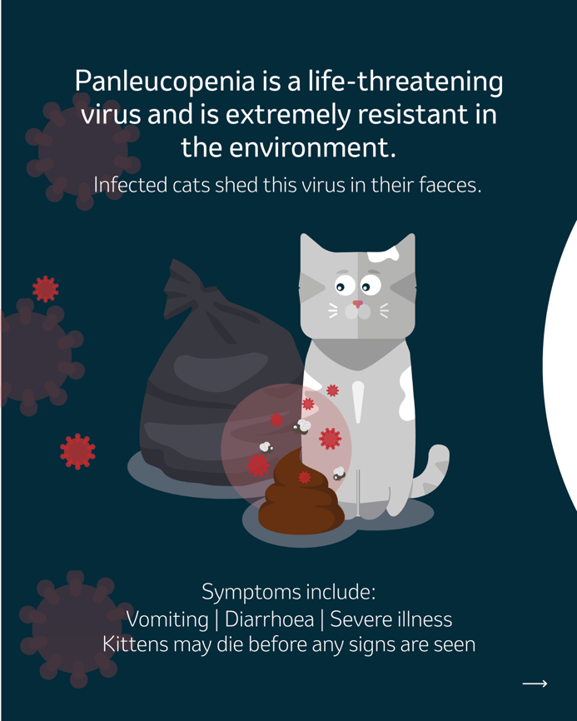 | 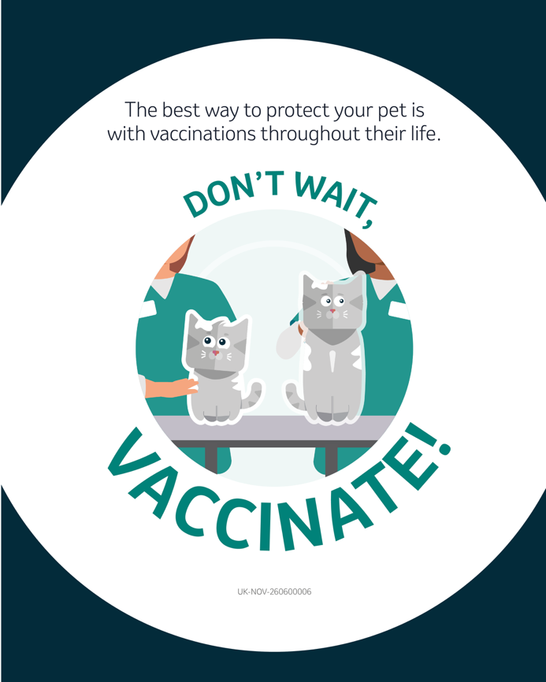
Suggested Caption: Panleucopenia can be life-threatening for your cat. The best way to protect them is with vaccinations throughout their life. Don’t wait, vaccinate!

Indoor Cat Disease Risk

Option 1 | Option 2
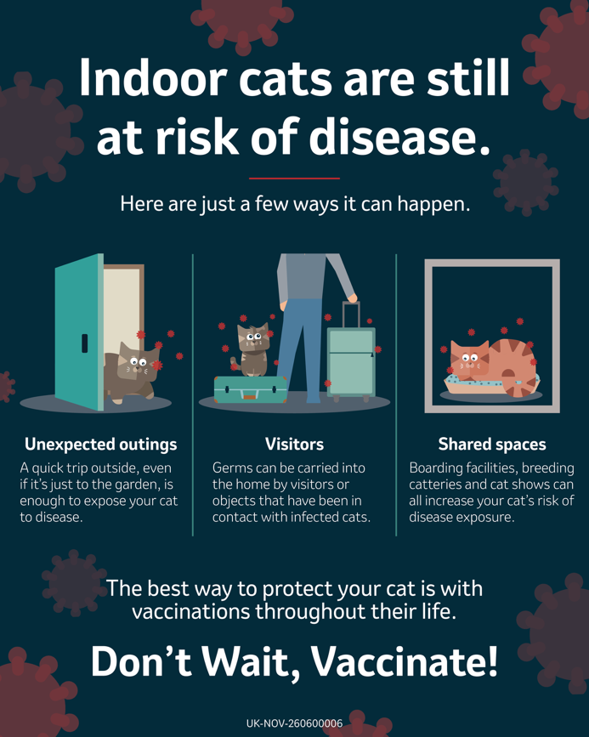 | 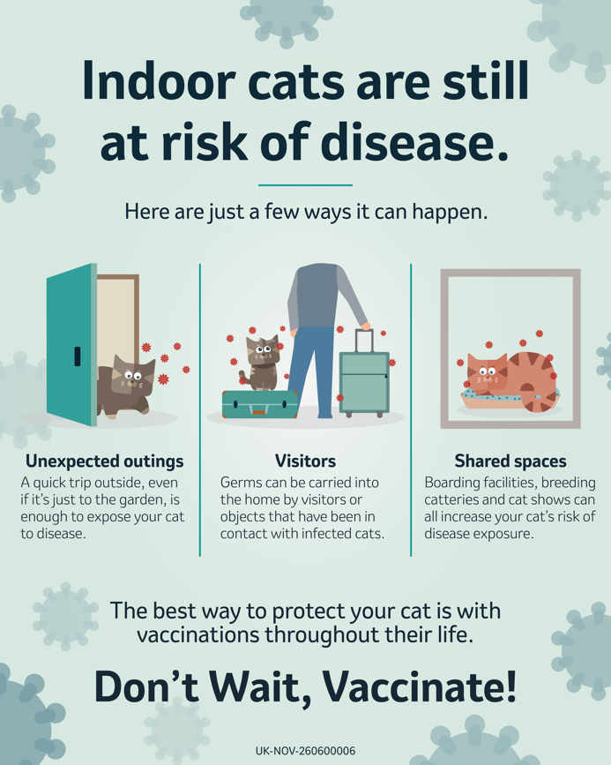
Suggested Caption: Indoor cats are still at risk of disease. The best way to protect your cat is with vaccinations throughout their life. Don’t wait, vaccinate!

Outdoor Cat Disease Risk

Option 1 | Option 2
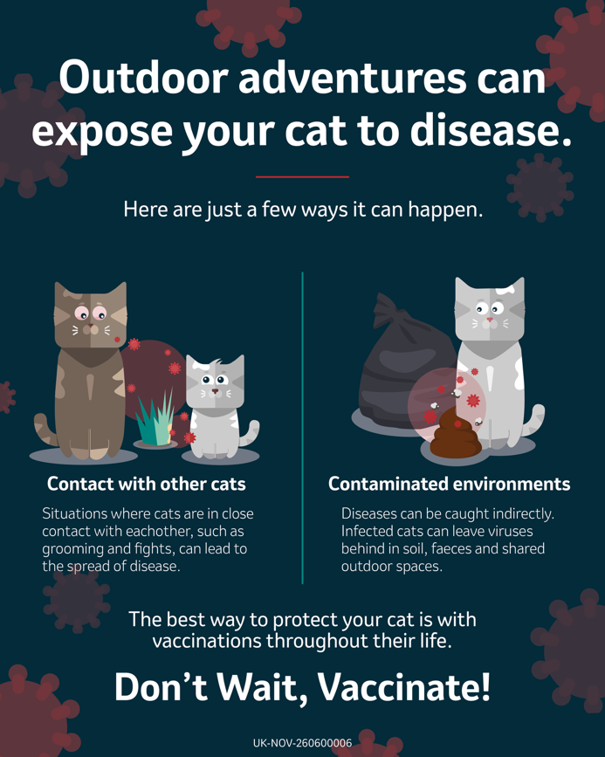 | 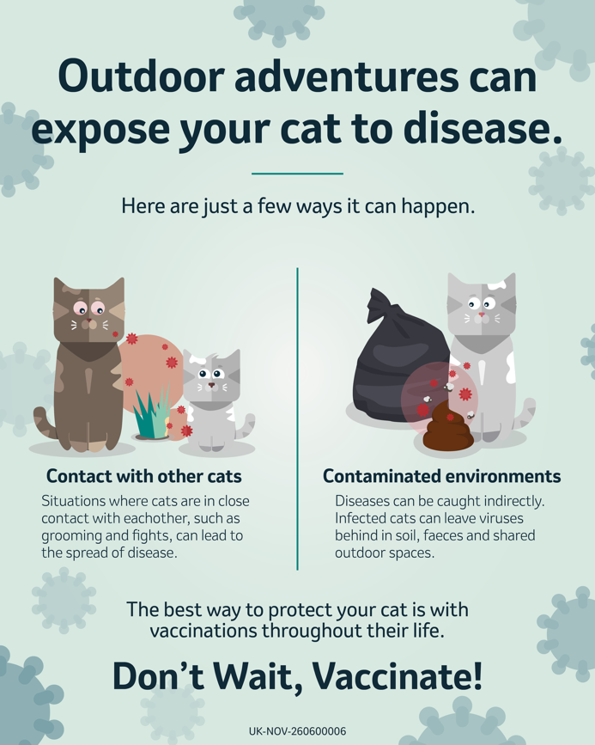
Suggested Caption: Cats that like to explore the outdoors are at high risk of coming into contact with diseases. The best way to protect your cat is with vaccinations throughout their life. Don’t wait, vaccinate!

General Disease Risk

Option 1 | Option 2
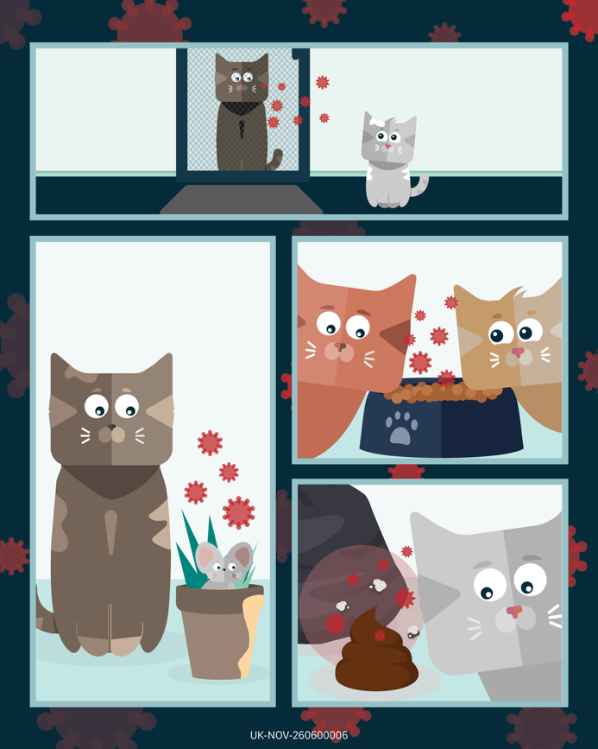 | 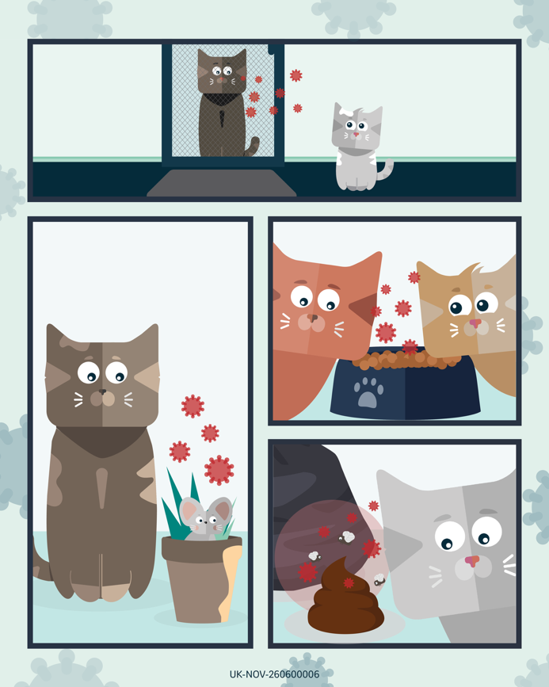
Suggested Caption: Cats can pick up diseases from lots of places, through both direct and indirect contact. The best way to protect your cat on their everyday adventures is with vaccinations throughout their life. Don’t wait, vaccinate!

Vaccination Myths: Boosters

Option 1 | Option 2
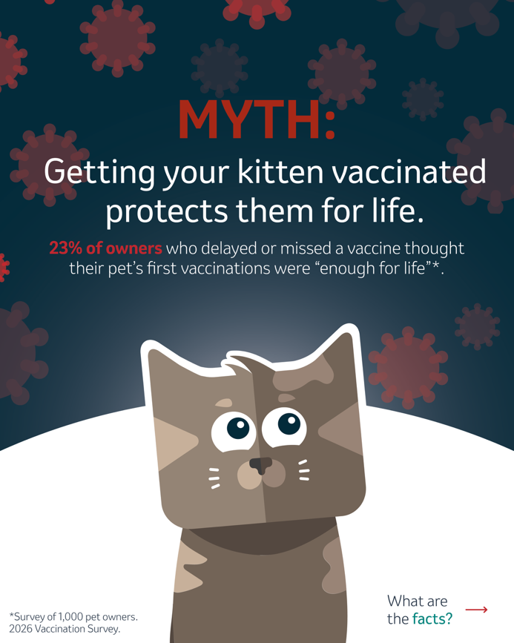 | 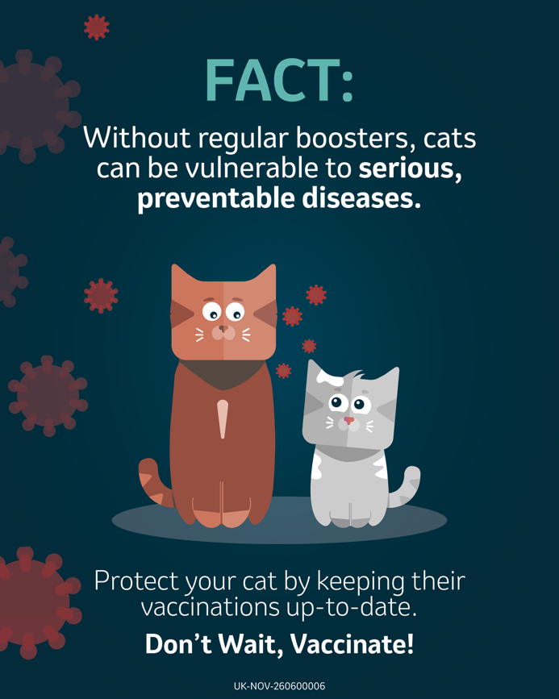
Suggested Caption: It’s a common misconception that vaccinated kittens are protected for life, which can leave cats dangerously exposed to serious diseases that are preventable with regular vaccination. Don’t wait, vaccinate!

Vaccination Myths: Hidden Disease Risk

Option 1 | Option 2
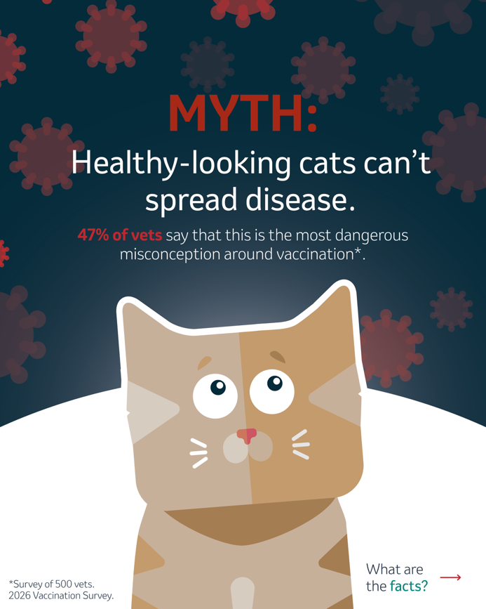 | 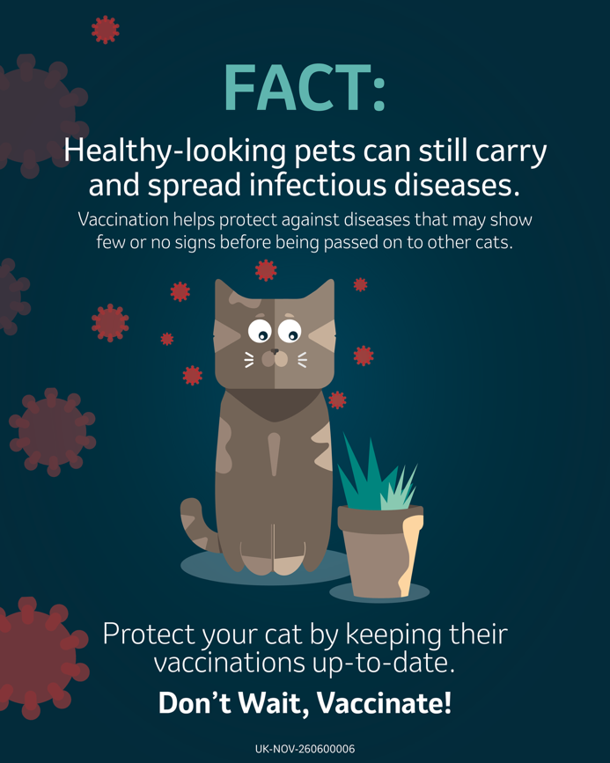
Suggested Caption: Healthy-looking cats can still carry and spread infectious diseases, even when there are no obvious signs of illness. Staying up to date with vaccinations is one of the best ways to help keep cats protected. Don’t wait, vaccinate!

